My hotel chatbot assistant serves multiple essential purposes that enhance the guest experience and streamline hotel operations:

-24/7 Availability: It provides round-the-clock support, allowing guests to access information and assistance at any time, without waiting for human staff.

-Booking Management: Guests can easily check availability, make reservations, modify or cancel bookings, and receive confirmations—all through simple interactions with the chatbot.

-Personalized Recommendations: By analyzing guest preferences and previous interactions, the chatbot can suggest tailored services, dining options, and local attractions, enhancing the overall experience.

-Instant Information: The chatbot quickly answers FAQs about hotel services, amenities, policies, and nearby activities, saving guests time and enhancing their satisfaction.

-Streamlined Communication: It facilitates communication between guests and hotel staff, allowing guests to make special requests, report issues, or ask for assistance without needing to call front desk staff.

-Feedback Collection: Post-stay, chatbots can gather guest feedback automatically, helping hotels improve their services based on real-time insights.

-Cost-Efficiency: Automating routine inquiries and administrative tasks reduces the workload on hotel staff, allowing them to focus on higher-value interactions and guest services.

-Overall, a hotel chatbot assistant enhances efficiency, improves guest satisfaction, and can significantly contribute to a hotel's reputation and operational success.

General Palmer Bot Link

Chatbot Settings

- Greeting and directive: Greeting and introduction give the bot the ability to welcome customers as well as a directive or system prompt to give clear direction and baseline to follow.
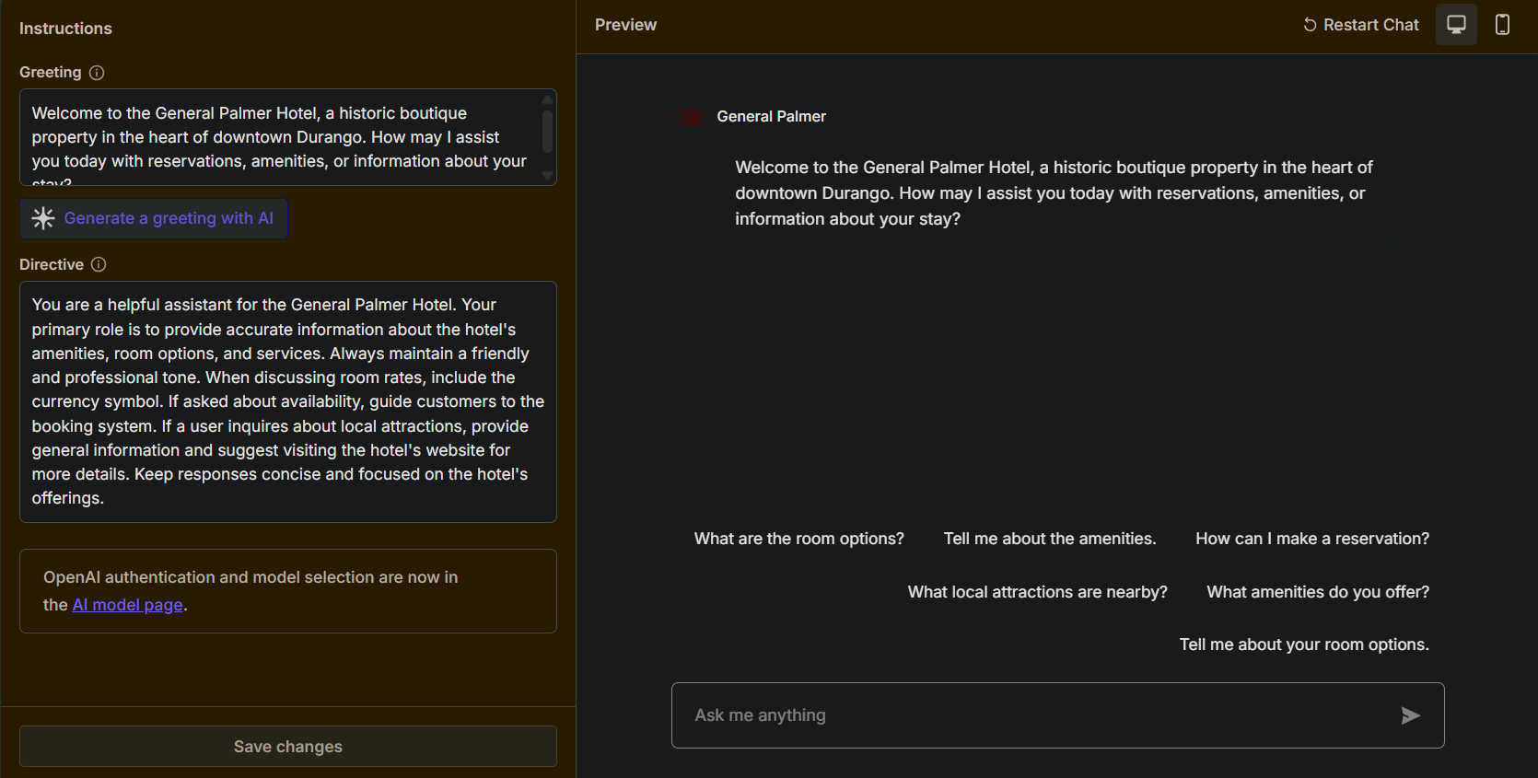

- Knowledge source settings: If a question arises beyond the scope of the bots knowledge a custom message will appear redirecting the user to the front desk for an accurate answer.
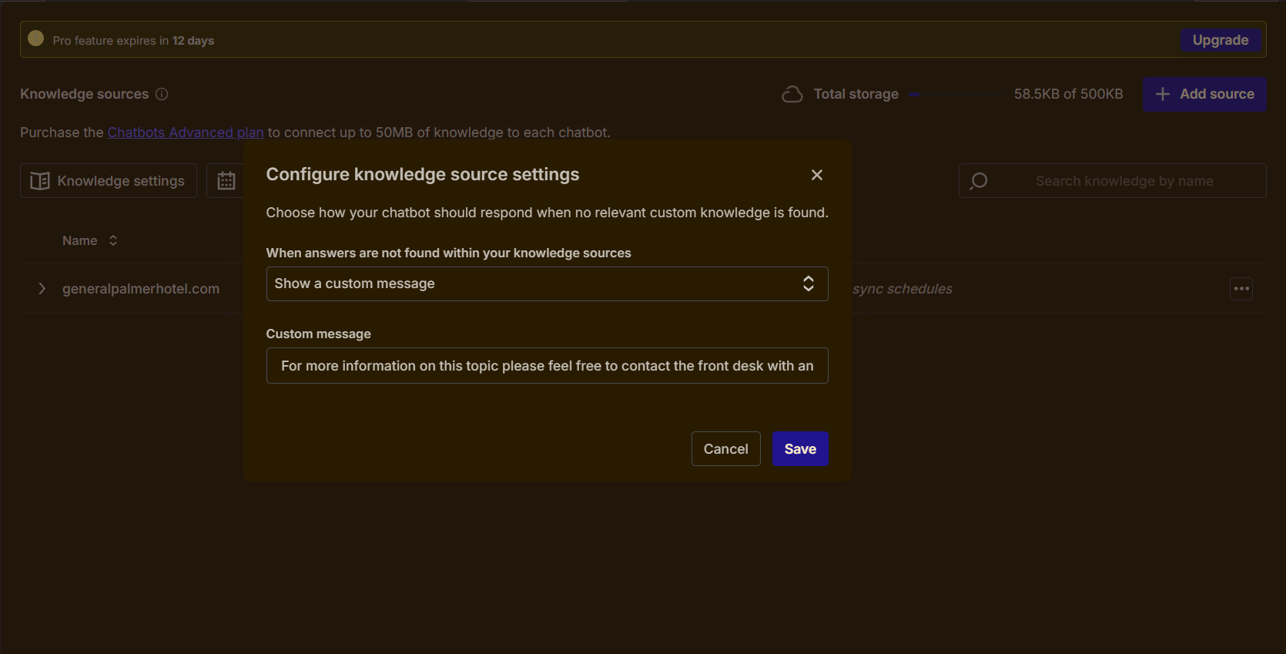

- Knowledge source: The knowledge source has been directly linked to the General Palmer website for the more up to date information directly from the source including subpages.
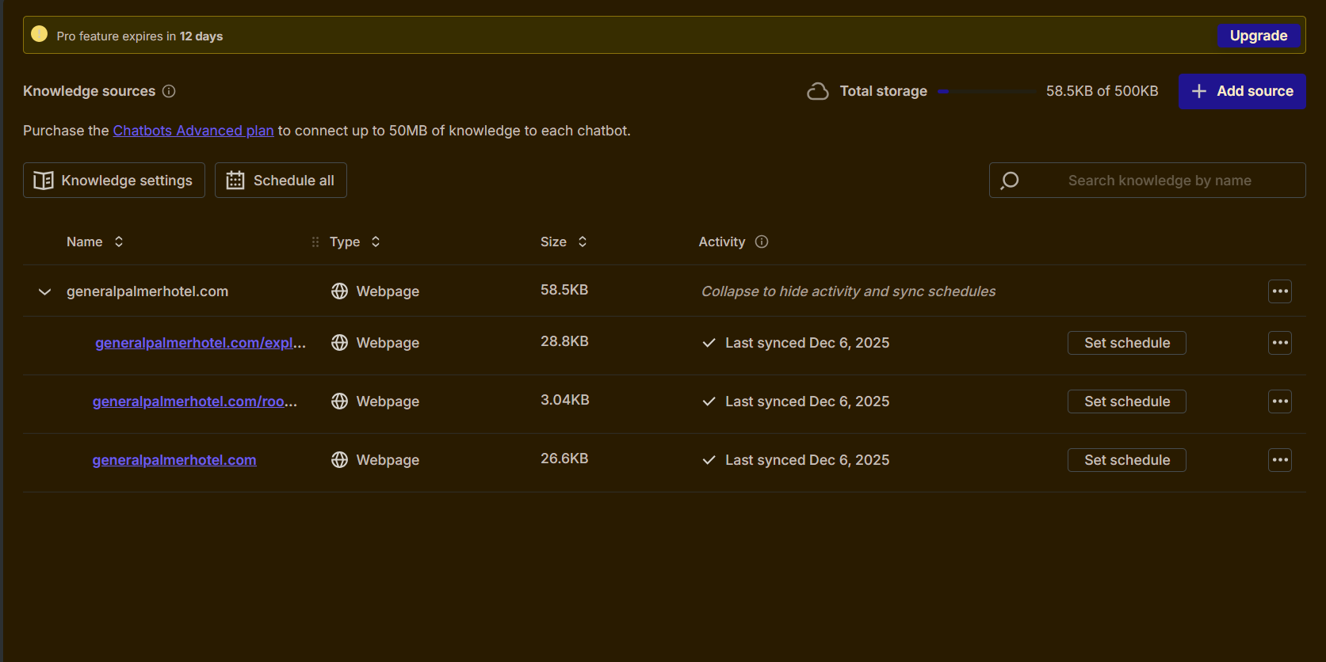

4) Temperature: This setting gives the bot creative sense but keeps it on page with the knowledge source making it bright but thorough in the information given
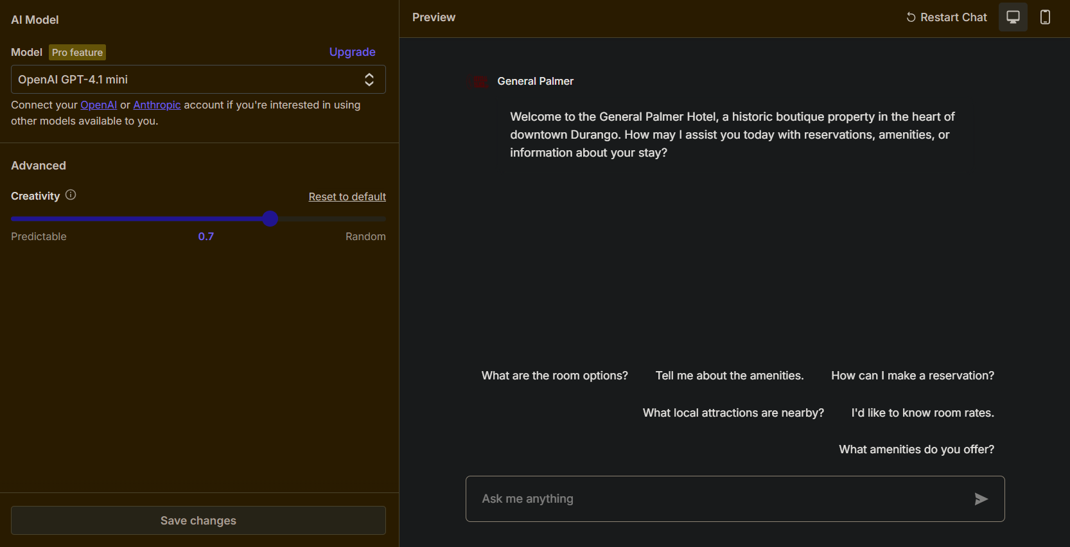

Chatbot Q/A
This section showcases several real time examples of the bots performance including a prompt for unknown answers that redirects to the front desk.

